OAuth Token Step

Objective

OAuth is an authentication protocol that allows a user (resource owner) to grant a third-party application (consumer/client) access to their information on another site (resource).

Access tokens are the thing that applications use to make API requests on behalf of a user. The access token represents the authorization of a specific application to access specific parts of a user's data. Access tokens must be kept confidential in transit and in storage

UI

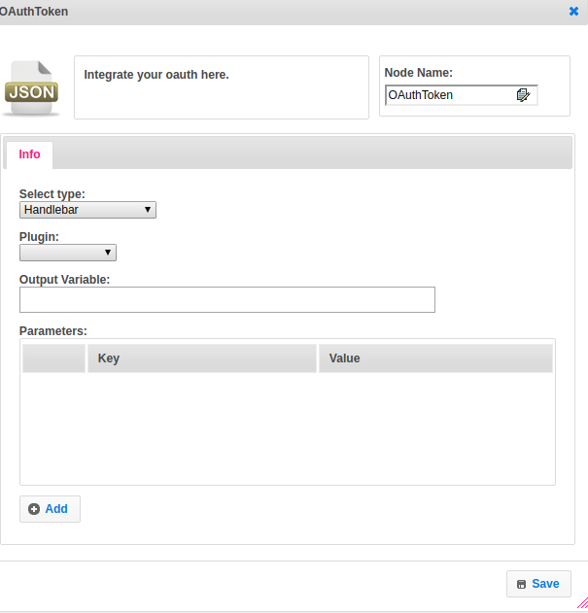

## Attributes

|  |  |
| --- | --- |
| **Attributes** | **Description** |
| **1. Select Type** | Value_type used to set the value type.  Value types are two types.  1.hb-HandleBars  2.ftl-Freemarker Template Language. |
| **2. Plugin** | Contains the name of the plugin. |
| **3. Params** | Param contains the list of key and value pair. |
| **4. Output Variable** | Used to store the response of the request. |

## ￼Executor Description

By using plugin name get the plugin information. Get the ServiceBuilder object by calling the get method and Identity Plugin object by calling a get-config method from the pluginHandler class. A set version of Oauth is 2 by default. Concatenating scopes if not null. Get the code from Http Request query parameter from URL. Call the ServiceBuilder class build method by passing plugin scribe class. Get the accessToken and convert into JsonTree and put the result into map key as output_variable and result as value.

## 

## Resource

For more information please refer the following link.

<https://developers.google.com/identity/protocols/OAuth2>